

|  |
| --- |
| PERFORMANCE ASSESSMENT OF  DATA MINING II  TASK3  D212  BY KOFFI M. GANU |
| MSDA MAY 2022 AT WGU  INSTRUCTOR: KESSELLY KAMARA  Phone  Email |

**INTRODUCTION**

People often say in business: “It takes a month to find a customer but a second to lose one.” The primary goal of any company is to maintain its customers as long as possible. It is with this in mind that, especially with the advent of the use of data, these companies hire data specialists (Data analysts, Data scientists) for strategies and recommendations for the improvement of their company’s services. In the rest of our project, we will use market basket analysis to uncover relationships between different products or actions that customers engage in before churning. We will use this information to target efforts to retain customers and improve overall satisfaction.

**PART I/**

A1-

How can we identify patterns and associations in customer behavior to understand the factors that contribute to customer attrition and potentially reduce churn?

A2-

One goal of market basket analysis is to uncover associations and patterns in customer purchasing behaviors to identify frequently co-occurring items in transactions. This will help businesses understand which products or services are often purchased together, enabling them to make informed decisions for product placement. Finally, this method enhances the customer experience, increases sales, and optimizes business operations.

**PART II/**

B1

Maret basket is a data mining technique that aims to uncover associations and relationships between items frequently purchased or used together. This technique is often used in retail and e-commerce to understand customer purchasing behaviors and improve business strategies. The analysis begins by calculating the frequency of each item. Then the algorithm creates combinations of items, known as itemsets. These itemsets contain multiple items that are often purchased together.

B2- Example of transaction in the dataset.

['Logitech M510 Wireless mouse', 'HP 63 Ink', 'HP 65 ink', 'nonda USB C to USB Adapter', '10ft iPHone Charger Cable', 'HP 902XL ink', 'Creative Pebble 2.0 Speakers', 'Cleaning Gel Universal Dust Cleaner', 'Micro Center 32GB Memory card', 'YUNSONG 3pack 6ft Nylon Lightning Cable', 'TopMate C5 Laptop Cooler pad', 'Apple USB-C Charger cable', 'HyperX Cloud Stinger Headset', 'TONOR USB Gaming Microphone', 'Dust-Off Compressed Gas 2 pack', '3A USB Type C Cable 3 pack 6FT', 'HOVAMP iPhone charger', 'SanDisk Ultra 128GB card', 'FEEL2NICE 5 pack 10ft Lighning cable', 'FEIYOLD Blue light Blocking Glasses']

B3-

One assumption of market analysis is the apriori principle, which states that if an itemset is frequent, then all its subsets are also frequent. This assumption is fundamental to the efficiency of the apriori algorithm, a method for performing market basket analysis.

PART III/

C1

To transform the dataset into a suitable format for market basket analysis, we need a format where each row represents a transaction and the items purchased in that transaction are listed.

The clean dataset will be attached and named “clean_D212_task3”.

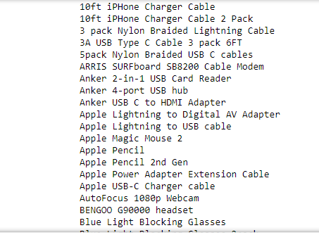

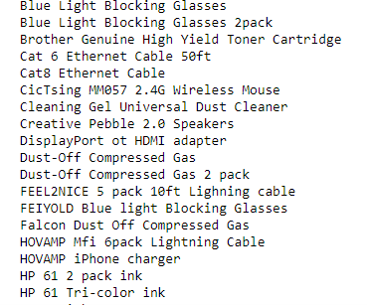

C2



C3

Here is the screenshot of the association rule table. In this table, we can see the values of support, confidence, and lift.

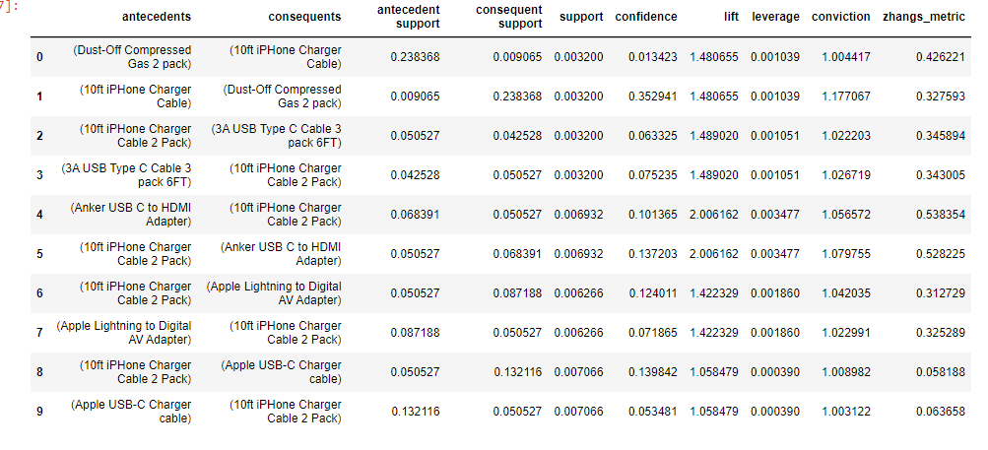

C4

In order to identify the top three rules generated by the apriori algorithm, we need to sort the rules based on a specific metric as support. The screenshot below shows us the result.

PART IV/

D1

Support, Confidence, and Lift are three metrics used together in Market Basket analysis to filter and select exciting and meaningful association rules. High support helps in identifying common itemsets. High confidence filters for strong associations, and high lift point out rules substantial non-random connection. After analysis, 10ft iphone charger cable, 10ft iphone charger cable 2pack, and 3 pack Nylon Braided Lightning Cable are the top three support. Also, we have seen in the association rule table that these three items have high lift and high confidence when combined with Dust-Off Compressed Gas 2 pack, 3A USB Type C Cable pack 6ft, and Apple Lightning to Digital AV Adapter.

D2

The Market Basket analysis for this dataset tells us 10ft iphone charger cable can be purchased with Dust-Off Compressed Gas 2 pack and 10ft iPHone Charger Cable 2 Pack with 3A USB Type C Cable pack 6ft.

D3

Recommendation After analysis, we identified co-purchased items, such as 10ft iphone charger cable, Dust-Off Compressed Gas 2 pack, and 10ft iPHone Charger Cable 2 Pack with 3A USB Type C Cable pack 6ft, and in other hand discovered potential cross-selling opportunities and uncovered unexpected associations. This information can help monitor customer behavior.

PART V/

E- PANOPTO VIDEO

https://wgu.hosted.panopto.com/Panopto/Pages/Viewer.aspx?id=a7025dfd-a9a7-4e00-9de3-b07300767260

F-

Data camp course

D212 Predictive modeling WGU textbook

D212 Predictive modeling WGU course webinar

G-

No in-text references were used.

H-

We used professional communication in the presentation of the submission.